WLC based WLAN

Background / Scenario
An organization is centralizing control of their wireless LAN by replacing their standalone access points with lightweight access points (LAP) and a wireless LAN controller (WLC). You will be leading this project and you want to become familiar with the WLC and any potential challenges that may occur during the project. You will configure a WLC by adding new wireless networks and securing them with WPA-2 PSK security. To test the configuration, you will connect a laptop to the WLANs and ping devices on the network. The initial steps have been configured for you in the WLAN on WLC.pkt.

Topology
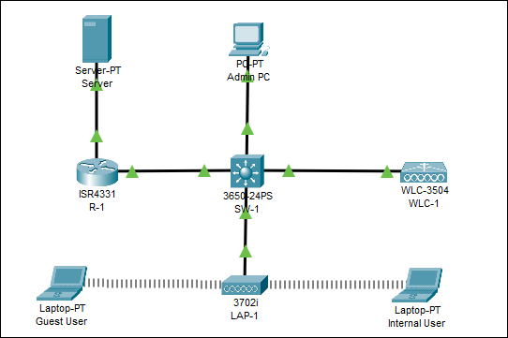

Addressing Table
Device | Interface | IP Address
R-1 | G/0/0 | 172.31.1.1/24
 | G0/0/1.5 | 192.168.5.1/24
 | G0/0/1.10 | 192.168.10.1/24
 | G0/0/1.200 | 192.168.200.1/24
SW-1 | VLAN 200 | 192.168.200.100/24
LAP-1 | G0 | DHCP
WLC-1 | Management | 192.168.200.254/24
Server | NIC | 172.31.1.254/24
Admin PC | NIC | 192.168.200.200/24
Wireless Hosts | Wireless NIC | DHCP

Objectives
In this lab, you will explore some of the features of a wireless LAN controller. You will create new WLANs on the controller and implement security on thoseW LANs. Then you will configure wireless hosts to connect to the new WLANs through an AP that is under the control of the WLC. Finally, you will verify connectivity.
- Connect to a wireless LAN controller GUI.
- Explain some of the information that is available on the WLC Monitor screen.
- Configure a WLAN on a wireless LAN controller.
- Implement security on a WLAN.
- Configure a wireless host to connect to a wireless LAN.

Instructions

Monitor the WLC
Open WLAN on WLC.pkt and wait until all link lights are green.
      - Go the desktop of Admin PC and open a browser. Enter the management IP address of WLC-1 from the addressing table into the address bar. You must specify the HTTPS protocol. https://192.168.200.254
      - Click Login and enter these credentials: User Name: admin, Password: Cisco123. After a short delay, you will see the WLC Monitor Summary screen.
      - Scroll through the Monitor Summary screen.
What can be learned from this screen?
Is the WLC connected to an AP?
Click Detail next to the All APs entry in the Access Point Summary section of the page. What information can you find about APs on the All APs screen?

Create a Wireless LAN
Now you will create a new wireless LAN on the WLC. You will configure the settings that are required for hosts to join the WLAN.

Create and enable the WLAN.
      - Click WLANs in the WLC menu bar. Locate the dropdown box in the upper right had corner of the WLANs screen. It will say Create New. Click Go to create a new WLAN.
      - Enter the Profile Name of the new WLAN. Use the profile name Internal Users. Assign an SSID of Internal to the WLAN. Hosts will need to use this SSID to join the network.
      - Select the ID for the WLAN. This value is a label that will be used to identify the WLAN is other displays. Select a value of 5 to keep it consistent with the VLAN number and SSID. This is not a requirement but it helps with understanding the topology.
      - Click Apply so that the settings go into effect.
      - Now that the WLAN has been created, you can configure features of the network. Click Enabled to make the WLAN functional. It is a common mistake to accidentally skip this step.
      - Choose the VLAN interface that will be used for the WLAN. The WLC will use this interface for user traffic on the network. Click the drop-down box for Interface/Interface Group (G). Select the Internal-WLAN interface. This interface was previously configured on the WLC for this activity.
      - Click the Advanced tab.
      - Scroll down to the FlexConnect portion of the page. Click to enable FlexConnect Local Switching and FlexConnect Local Auth.
      - Click Apply to enable the new WLAN. If you forget to do this, the WLAN will not operate.

Secure the WLAN.
The new WLAN currently has no security in place. This WLAN will initially use WPA2-PSK security. For larger wireless networks, use WPA2-Enterprise provides a much better solution.
      - In the WLANs Edit screen for the Internal WLAN, click the Security tab. Under the Layer 2 tab, select WPA+WPA2 from the Layer 2 Security drop down box. This will reveal the WPA parameters.
      - Click the checkbox next to WPA2 Policy. This will reveal additional security settings. Under Authentication Key Management, enable PSK.
      - Now you can enter the pre-shared key that will be used by hosts to join the WLAN. Use Cisco123 as the passphrase.
      - Click Apply to save these settings.
Note: It is not a good practice to reuse passwords when configuring security. We have reused passwords in this activity to simplify configuration.

Verify the Settings
      - After Applying the configuration, click Back. This will take you back to the WLANs screen.
What information about the new WLAN is available on this screen?
      - If you click the WLAN ID, you will be taken to the WLANs Edit screen. Use this to verify and change the details of the settings.

Connect a Host to the WLAN
      - Go to the desktop of Internal User and click the PC Wireless tile.
      - Click the Connect tab. After a brief delay you should see the SSID for the WLAN appear in the table of wireless network names. Select the Internal network and click the Connect button.
      - Enter the pre-shared key that you configured for the WLAN and click Connect.
      - Click the Link Information tab. You should see a message that confirms that you have successfully connected to the access point. You should also see a wireless wave in the topology showing the connection to LAP-1.
      - Click the More Information button to see details about the connection.
      - Close the PC Wireless app and open the IP Configuration app. Verify that Wireless Host has received a non-APIPA IP address over DHCP.
      - From Wireless Host, ping the WLAN default gateway and the Server to verify that the laptop has full connectivity.

Create a new WLAN
You will now create another WLAN for Guests Users and it should be on a separate network/VLAN. You will configure the interface and the WLAN and appropriate settings on the router and switch to support this new network.
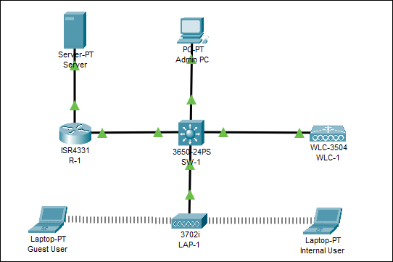

Create a new interface on the Controller
      - Go the desktop of Admin PC and log back in WLC-1 at https://192.168.200.254
      - Configure a Dynamic Interface on the WLC for the Guest Users. Click on "CONTROLLER" tab and then "Interfaces".
      - Click on new and create a Guest-WLAN interface with a VLAN 10. Click apply. The details of the Guest network are as follows:
Guest-WLAN
VLAN Id : 10
IP address: 192.168.10.254
Netmask: 255.255.255.0
Gateway: 192.168.10.1
Physical port on WLC: 1
DHCP server: 192.168.10.1
      - Click apply to apply the configuration and back to go back to the interfaces.

Create and enable the WLAN.
      - Click WLANs in the WLC menu bar.
      - Then Locate the dropdown box in the upper right had corner of the WLANs screen. It will say Create New. Click Go to create a new WLAN.
      - Enter the Profile Name of the new WLAN. Use the profile name Guest Users. Assign an SSID of Guest to the WLAN. Hosts will need to use this SSID to join the network.
      - Select the ID for the Guest WLAN as "Guest". This value is a label that will be used to identify the WLAN is other displays. Select a value of 10 to keep it consistent with the VLAN number and SSID.
      - Click Apply so that the settings go into effect.
      - Now that the WLAN has been created, you can configure features of the network. Click Enabled to make the WLAN functional.
      - Choose the VLAN interface that will be used for the WLAN. The WLC will use this interface for user traffic on the network. Click the drop-down box for Interface/Interface Group (G). Select the Guest-WLAN interface.
      - Click the Advanced tab and Scroll down to the FlexConnect portion of the page. Click to enable FlexConnect Local Switching and FlexConnect Local Auth as you did before and click apply.

Secure the WLAN.
Secure the new WLAN following the same steps you used for the Internal WLAN

Switch configuration
You need to configure the switch to support the new VLAN of the Guest WLAN.
      - Verify the configuration on the switch interface. Using show run on the switch, what information can you observe on the different ports connected to the WLC, the router and the LAP?
      - Check the VLANs configured on the switch using show vlan brief. How many VLANs are already configured?
      - You now need to configure a VLAN to carry the Guest traffic. Remember you set a VLAN ID of 10 on the WLC
Switch(config)#vlan 10
Switch(config-vlan)#name GuestUsers
      - Verify that the VLAN has been created.

Configure the router as DHCP server for the two WLANs
      - Using show ip dhcp pool and show run, verify the DHCP settings for the Internal users. You will do similar configuration for the Guest users
Router(config)#ip dhcp excluded-address 192.168.10.1
Router(config)#ip dhcp pool GuestClients
Router(dhcp-config)#network 192.168.10.0 255.255.255.0
Router(dhcp-config)#default-router 192.168.10.1

Configure inter-vlan routing on the router
      - The router will now be configured to provide routing between the new created WLAN and the rest of the network. Using show run, observe the use of subinterfaces and the 802.1q protocol in a scheme know as Router on a stick.
      - Configure the subinterface for the new WLAN/VLAN with the appropriate IP address
Router(config)#int gigabitEthernet 0/0/0.10
Router(config-subif)#encapsulation dot1Q 10
Router(config-subif)#ip address 192.168.10.1 255.255.255.0

Connect a Host to the Guest WLAN
      - Go to the desktop of Guest User and click the PC Wireless tile.
      - Click the Connect tab. After a brief delay you should see the SSID for the WLAN appear in the table of wireless network names. Select the Guest network and click the Connect button.
      - Enter the pre-shared key that you configured for the WLAN and click Connect.
      - Verify that Wireless Host has received a non-APIPA IP address over DHCP.
      - From Guest Wireless Host, ping the WLAN default gateway and the Server to verify that the laptop has full connectivity.

Connect a new AP
Using what you have learnt, connect a new LAP to support the two WLANs available on the network.
Hint: using show run on the switch, observe the configuration required on the interface connected to the LAP. Similar settings must be done on the interface connected to the new LAP.
